Chartfield Lookup

Updated in October 2025 with modern styling to align better with other University webpages. The URL for the Chartfield Lookup and all existing features and functions remain the same.

Updated Design:
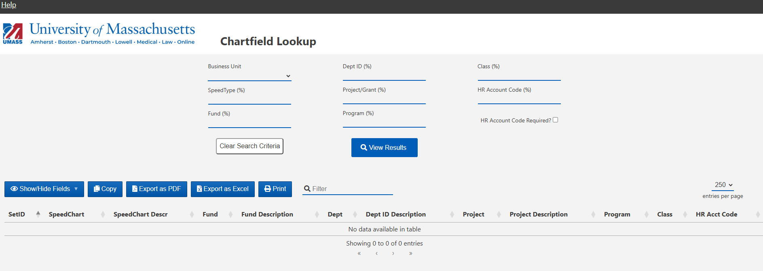

Key Features:
- Dropdown selection for Business Unit
  - Business Unit is required for all lookup inquiries
- Use wildcard (%) to enter partial search criteria (Ex: Enter a Business Unit, then a partial speedtype, 1297% and search.
- Copy displayed rows to the clipboard
- Export as either PDF or to Excel
- Filter – enter additional criteria to limit the results displayed
- Searches are not case sensitive (ex: A812300000 or a8123000000 both return results)

